**Influence of the applied-pressure on the microstructure evolution of W-Cr-Y-Zr alloy during the FAST process**

*S.P. Yang1a, W.J. Wang1a, X.Y. Tan1,2⁎, H.J. Zhu1, A. Litnovsky2,4, F. Klein2, J.W. Coenen2,5, Ch. Linsmeier2, L.M. Luo1, P. Li1, Y.C. Wu1,3*

*1School of Materials Science and Engineering, Hefei University of Technology, Hefei, 230009, China 2Forschungszenturn* *Jülich GmbH, Institut für Energie- und Klimaforschung –* *Plasmaphysik, Partner of the Trilateral Euregio Cluster (TEC), Jülich, 52425, Germany*

*3Key Laboratory of Interface Science and Engineering of New Materials, Ministry of Education, Taiyuan University of Technology, Taiyuan, 030024, China*

*4National Nuclear Research University MEPhI, Kashirskoe sh.31, 115409, Moscow, Russian Federation*

*5Department of Engineering Physics, University of Wisconsin - Madison, Madison, WI 53706, USA*

**Abstract**: Field assisted sintering technique (FAST) has been widely employed to manufacture powder materials. The assisted-current and applied-pressure in FAST facility would strongly effect on the microstructures of the consolidated powder materials. In this work, we investigated the influence of the applied-pressure on the W-11.4Cr-0.6Y-0.4Zr alloy during FAST consolidation at 1400 °C by varying the applied-pressures (10 MPa-60 MPa). From the microstructure observation of the sintered samples, the amounts of Cr-rich phase in W-Cr-Y-Zr sintered samples decreases with an increase of the applied-pressure. This is owing to the local overheating in porous sample, which enhances the Cr precipitation during the FAST process. In addition, the average grain size increases as the applied-pressure rises from 10 MPa to 40 MPa. With the further rise of applied-pressure to 60 MPa, the average grain size decreases to 0.14 μm. High applied-pressure induced the deformation of the graphite punch, which results in a low horizontal thermal resistance. Therefore, the reduction of the grain size is mainly related to the low actual temperature of the sample. Under an applied-pressure of 60 MPa, the high density (~99.5%), fine grain and homogeneous microstructure of W-11.4Cr-0.6Y-0.4Zr alloy can be obtained.

**Keywords**: Field assisted sintering technique; self-passivating tungsten alloys; Cr-rich phase; Grain size; Homogeneous microstructure

**1. Introduction**

Self-passivating tungsten alloys (SPTAs) with good oxidation resistance become a candidate material for the first wall in future fusion reactors to avoid a radiation leakage risk from the loss-of coolant accident and vacuum break [1]. In SPTA system, chromium (Cr) component has been considered as the promising passivating element for the formation of the oxide scale to prevent the tungsten (W) oxidation [2]; the yttrium (Y) and zirconium (Zr) are the optimized active elements used to improve the microstructure of the oxide scale and enhance the adhesive property between the oxide scale and SPTA matrix [3-5].

It has reported that an excellent anti-oxidation performance of SPTA requires several characteristics such as high density, microfine grain and homogeneous microstructure [6]. Due to the W alloy with high melting point, the SPTA bulk samples were manufactured following a powder metallurgy route of mechanical alloying and then hot isostatic pressuring (HIP) [7] or field assisted sintering technology (FAST) [8]. Since the sintering process of the powder materials, there exists a conflict in selection of temperature to achieve both microfine grain and high density. High density means high sintering temperature, but high sintering temperature would result in coarse grain. In addition, the extra requirement of homogeneous microstructure further aggravates this contradiction. Therefore, the selection of sintering technique and the corresponding sintering process are critical for the SPTA consolidation. Generally, the HIP consolidation of SPTA bulks were always conducted at a temperature below the solution temperature. Naturally, duplex SPTA would be inevitably obtained.

FAST featured sintering technology with assisted-current and applied-pressure includes several advantages of high heating rate, low densification temperature and short sintering time, which has been employed widely for the production of refractory metal/alloy [9], nano-crystalline metals [10], functionally graded materials [11] and ceramic materials [12], etc. During the consolidation of conductive powder materials using FAST, the assisted-current could enhance atom diffusion and provide benefits to the densification process and grain growth [13]. In our recent work [14], we studied the influence of heating rate on the W-Cr-Zr alloy densification process and microstructure evolution during FAST process by changing the heating rate from 50 °C/min to 300 °C/min. According to the densification curves, the densification temperature is ~1380 °C. It could be concluded that high heating rate means high current flowing through the bulk, which could improve the densification rate and also positively affect the homogeneity of the microstructure.

However, rather few attention has been paid to the impact of the applied-pressure on the densification behavior of powder materials. In powder system, there exists soft and hard agglomerates [15]. The soft ones are the physical agglomerate particles formed due to the existence of van der Waals forces among fine powder particles [16]. After mechanical alloying, the alloyed powders are the hard agglomerate particles owing to the deformation, cold-welding and cracks [17,18]. An applied-pressure during the consolidation process can break the soft agglomerates and cause the prompt densification process through the particle rearrangement [19]. However, it is difficult to brake hard agglomerates. Several studies reported that the applied-pressure can enhance mass transport by the mechanisms of diffusion (grain boundary and particle displacement), and plastic flow and deformation [20-?]. During the sintering process, the relationship between density (*ρ*) of the powder materials and the effective pressure (*P*) acted on powder particles can be illustrated as [21]. It has demonstrated that the applied-pressure would be benefit to the densification of powder materials.

In this work, we consolidate the SPTA of W-Cr-Y-Zr quaternary alloy by FAST at a sintering temperature of 1400 °C. Investigation of the applied-pressure influences on the microstructure evolution of the W-Cr-Y-Zr alloy.

**2. Experiment**

2.1. Material preparation

The studied material is W-11.4Cr-0.6Y-0.4Zr quaternary alloy (all compositions are represented in wt.%). The elemental components of the W-Cr-Y-Zr alloy are originated from the W (99.9%, 5 μm), Cr (99.9%, 74 μm), Y (99.5%, 74μm), and zirconium hydride (ZrH2, 99.9%, 74 μm) powders. The content of ZrH2 was calculated by stoichiometry according to the composition of the W-11.4Cr-0.6Y-0.4Zr alloy. Based on the composition, these raw powders were processed by mechanical milling. The details on the mechanical alloying process is similar to those in our previous work in [14].

The milled W-Cr-Y-Zr powder was consolidated in a FAST facility (Labox-350, Sinter land inc, Japan) with applied-pressure ranges from10 MPa to 60 MPa at a sintering temperature of 1400 °C. The configuration diagram of the sintered sample and graphite die in FAST facility is the same as in [14]. Fig. 1 shows the FAST consolidation process of the W-Cr-Y-Zr alloy. Before each consolidation process, the vacuum chamber of the FAST facility was pumped below 10 Pa and then the W-Cr-Y-Zr green compact was applied a pressure of 10 MPa. The FAST facility in this study was operated in an artificial heating mode according to the electrical current curves. At the heating stage, a current was drawn stepwise to the samples at a step rate of 200 A/min. Once the temperature reaches up to 1400 °C, the input current was shut down immediately and the sample was cooled with the FAST facility. To relieve smoothly the residual gas in green compact, the applied-pressure was gradually loaded up to the designed pressure value when the temperature was heated up to 800 °C. The applied-pressure was held until the temperature was cooled down to 1000 °C. After FAST consolidation, the dimension of resulting sintering sample was Ø20 mm in diameter and 5-6 mm in thickness.

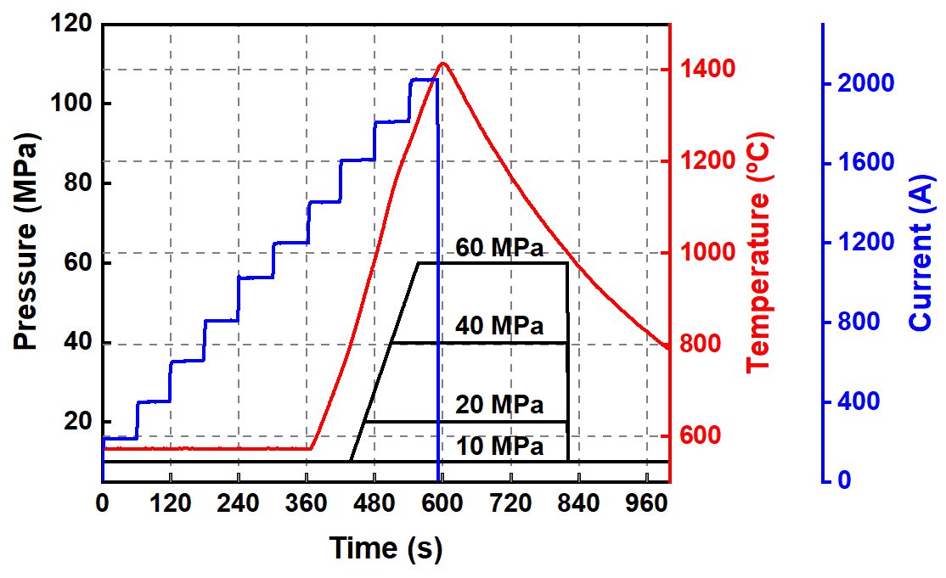

Fig. 1. The FAST consolidation process of the W-Cr-Y-Zr alloy sintered at 1400 °C with different applied pressure of 10 MPa, 20 MPa, 40 MPa and (d) 60 MPa.

2.2. Characterization

The phase components of the milled W-Cr-Y-Zr powder and the sintered bulks were measured by the X-ray diffraction (XRD, X'Pert PRO MPD, PANalytical B.V) operating at 40 kV and 40 mA scanned from 30° to 90° using Cu Kα radiation. The scanning speed is 6 °/min.

The microstructures or fracture morphologies of W-Cr-Y-Zr sintered samples were characterized by field emission scanning electron microscopy (FESEM, Gemini 300, Sigma Zeiss, Germany). Based on the fracture morphology containing at least 400 grains, the grain size for each samples were measured by the interception method [ref?]. The specimens for the microstructural examination were processed with grinding firstly and then mechanical polishing. Considering the fine grain of the W-Cr-Y-Zr samples after FAST consolidation and surface distortion during the grinding and polishing process, the mechanical polished specimens were further polished by three ion beam cutter (LEICA EM TIC 3X, Leica, Germany).

The density of the W-Cr-Y-Zr bulk samples after FAST consolidation were measured by the Archimedes’ principle. The relative density is defined as the ratio of the measured density and the theoretical density. Notably, the theoretical density is simply calculated based on the mixing rules. For the W-Cr-Y-Zr alloy, the theoretical density of W, Cr, Y and Zr elemental components were taken as 19.25 g/cm3, 7.19 g/cm3, 4.47 g/cm3 and 6.52 g/cm3, respectively. After calculation, the theoretical density of the W-11.4Cr-0.6Y-0.4Zr alloy is 15.79 g/cm3.

**3. Results and discussions**

3.1. XRD spectra

Fig. 2 shows the XRD spectra of the milled W-Cr-Y-Zr powder and the corresponding sintered samples at different pressures applied. It could be confirmed that the phase structure of the milled powder is body-centred cubic (bcc). In addition, no pure Cr peaks can be detected. It means that the Cr has completely dissolved into the W lattice. Notably, the XRD spectrum of the milled powder possess an obvious double-peak structure. It demonstrates that two compositions of W-Cr-Y-Zr alloyed powder could be made in the milled powder with similar components but with different W amounts. After FAST consolidation, a strong single-phase can be confirmed in W-Cr-Y-Zr samples. Notably, an obvious Cr-rich phase peak can be detected in the case of the W-Cr-Y-Zr sample sintered with an applied-pressure of 10 MPa.

C:\Users\鹤青云\Desktop\分开48.tif

Fig. 2. XRD spectra of the milled powder and the sintered W-Cr-Y-Zr samples.

3.2. SEM microstructure

To observe the phase composition in more detail, Fig. 3 shows the microstructures of W-Cr-Y-Zr samples sintered with different applied-pressures. Two representative grains of grey and dark could be discovered in Fig. 3. After the EDX characterization, the grey grains are the normal phase of W-Cr-Y-Zr alloy and the dark grains are the Cr-rich phases. The amounts of Cr-rich phase in W-Cr-Y-Zr sintered samples decreases with increase of applied-pressure. In case of the sample sintered with applied-pressure of 10 MPa, the largest of Cr-rich phases can be found in Fig. 3a, which coincide with the corresponding the XRD spectrum in Fig. 2. The Cr-rich phases could not be detected in sintered samples with applied-pressure of 20 MPa, 40 MPa and 60 MPa, which would be owing to the detection limitation of XRD detector. When the applied-pressure reaches 60 MPa, the Cr-rich phase is almost disappeared. In addition, the large magnification images were inserted in Fig. 3, several dots particles could be detected, which are the Y-containing or Zr-containing particles. However, it is difficulty to confirm the grain size of the sintered samples from the inserted images due the blurry grain boundaries.

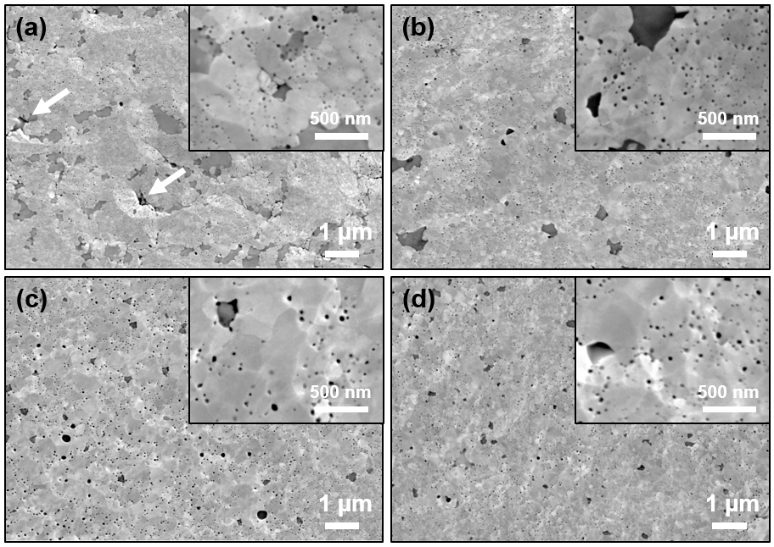

Fig. 3. Microstructure of the W-Cr-Y-Zr samples after FAST consolidation at 1400 °C with different pressure (a) 10 MPa; (b) 20 MPa; (c) 40 MPa; (d) 60 MPa.

Based on the W-Cr binary phase diagram [22], it can be deduced that the formation of Cr-rich phases requires the W-Cr-Y-Zr alloy to be held long enough at an enough high temperature but below its solution temperature. From the FAST consolidation process in Fig. 1, the high temperature lasts for several minutes only. In addition, the Cr has completely dissolved into W after the W-Cr-Y-Zr powder milling with 80 h [14]. It has reported that the assisted-current during FAST densification can enhance atom diffusion [23], which accelerates the formation of Cr-rich phase. From Fig. 3, large amount of Cr-rich phase is existed in W-Cr-Y-Zr sample sintered with a low applied-pressure of 10 MPa. During the compression process of the powder material, the lower pressing-pressure means more porous structures. High contact resistance would be existed at the contact region between two adjacent particles during the FAST consolidation process. In addition, when the applied electric current flows through the powder material, a local high electric current density will be existed at the place of particles contact. Therefore, high joule heat can be created in the area of particle contact, which results in the local overheating. Such an overheating would be the reason why the Cr-rich phases are presented in W-Cr-Y-Zr samples sintered with a low applied-pressure in Fig. 3.

3.3. Fracture morphology

The fracture morphologies of the W-Cr-Y-Zr sintered samples with different applied-pressure were presented in Fig. 4. Several pore structures can be detected in Fig. 3a and Fig. 3b, as marked with the white circles. As the applied-pressure increases, the pore structures decrease in density and disappeared. Based on the density calculation, the relative density of these samples sintered with different applied-pressure of 10 MPa, 20 MPa, 40 MPa and 60 MPa are 84.5%, 97.8%, 98.6% and 99.5%, respectively. When the W-Cr-Y-Zr samples sintered at 1400 °C with an applied pressure of 10 MPa, it is difficult to promote the powder particles to cause the desired displacement rearrangement. Thus, the sample has the lowest relative density. When increasing the pressure, the powder particles will undergo displacement-rearrangement and even plastic deformation, thereby increasing the density of the sample. It verifies directly that the applied-pressure is benefit to the W-Cr-Y-Zr alloy densification.

From the fracture morphologies in Fig. 4, homogeneous microstructure in grain size can be detected in samples sintered with applied-pressure of 10 MPa and 60 MPa. Unfortunately, the unusually large grain can be found in samples sintered with applied-pressure of 20 MPa and 40 MPa. Based on the previous discussions in Fig. 3, such large grains should be related to the local over-heating during the FAST consolidation process. In case of the W-Cr-Y-Zr sample sintered with 60 MPa, the high pressure would result in a uniform stress field and be benefit to the formation of homogeneous microstructure. In addition, the fracture modes of these sintered samples feature mainly intergranular fracture and partially transgranular fracture. Notably, the transgranular fracture could be occurred in unusually large grains.

C:\Users\鹤青云\Desktop\图改4\晶粒尺寸\晶粒尺寸1-15.tif

Fig. 4. Fracture morphologies of W-Cr-Y-Zr samples after FAST consolidation at 1400 °C with different pressure (a) 10 MPa; (b) 20 MPa; (c) 40 MPa and (d) 60 MPa.

According to the Fig. 4, the grain size of W-Cr-Y-Zr sample sintered with different applied-pressure are measured by the interception method. The distribution histogram of the grain sizes is shown in Fig. 5. After statistical calculation, the average grain size of the W-Cr-Y-Zr samples sintered with different applied-pressure of 10 MPa, 20 MPa, 40 MPa and 60 MPa are approximately 0.12 μm, 0.19 μm, 0.23 μm and 0.14 μm, respectively. The applied-pressure could promote the mass diffusion [19], thus, the average grain size of W-Cr-Y-Zr samples shows an increasing trend with the applied-pressure increases from 10 MPa to 40 MPa. Interestingly, further increasing the pressure up to 60 MPa, the average grain size decreases to ~0.14 μm. Apart from the applied-pressure accelerating the grain growth by promoting mass diffusion, it would induce the difference between the actual temperature and the detection temperature and will effect on grain size. From the configuration diagram of the sintered sample and graphite die in FAST facility [13], there exists a temperature difference between the detected temperature of the sample and the detection temperature, which is mainly determined by the horizontal interface thermal resistance and the thermal conductivity of graphite. In this work, all samples were consolidated using the same graphite die and punches. Therefore, the effect of the graphite thermal conductivity does not need to be considered. Increasing the applied-pressure would enhance the contact between the graphite die and the punches due to the thermal deformation of the graphite punches. Better contact means lower horizontal interface thermal resistance. Salvatore Grasso et. al [24] reported if the powder materials sintered at 1400 °C with the applied-pressure of 40 MPa and 60 MPa, the temperature differences between the actual temperature of sample and the detection temperature are approximately 270 °C and 200 °C, respectively. The lower actual temperature of the sample sintered with 60 MPa, it is reasonable to obtain the sintered sample with a fine grain size of ~0.12 μm. In addition, the high pressure induced uniform stress field could accelerate the uniform growth of the grains, which may be also benefit to achieve fine grain microstructure.

D:\E-Disk\Communication and cooperation\HGF-OCPC\2020中期答辩\晶粒尺寸1-35.tif

Fig. 5. The grain size of the W-Cr-Y-Zr sample after FAST sintered with different applied-pressure of (a) 10 MPa; (b) 20 MPa; (c) 40 MPa and (d) 60 MPa.

**4. Conclusion**

In this work, the SPTAs of W-Cr-Y-Zr samples were consolidated at 1400 °C using FAST facility varied different applied-pressure of 10 MPa-60 MPa. A high density (~99.5%), fine grain (~0.14 μm) and homogeneous microstructure of W-11.4Cr-0.6Y-0.4Zr alloy can be obtained under an applied-pressure of 60 MPa. The influence of the applied pressure on microstructure evolutions including the formation of Cr-rich phase and the grain size change were investigated. Two main conclusions can be drawn as below:

From XRD spectra and microstructures characterization, the Cr-rich phase in sintered W-Cr-Y-Zr samples disappears gradually with increase of applied-pressure. At lower pressing pressure, more porous structures in powder materials were detected. Due to the existence of porous structures and induced local high current, the local overheating can occur, lead to the formation of detected Cr-rich phase. When the applied-pressure reaches up to 60 MPa, the Cr-rich phase has almost disappeared.

Based on the fracture morphology of W-Cr-Y-Zr samples, the distribution histogram of the grain sizes was obtained. After statistical calculation, the average grain size shows an increasing trend with the applied-pressure increases from 10 MPa to 40 MPa. When the pressure increasing up to 60 MPa, the average grain size decreases to ~0.14 μm. Compared to sample sintered at 40 MPa, the reduction in grain size in case of sample sintered at 60 MPa is mainly because of the lower actual sintering temperature. It would be attributed to the reduction in the horizontal thermal resistance between the graphite punches and the graphite die due to the high applied-pressure induced deformation.

**Acknowledgements**

This work is supported by the National Natural Science Foundation of China (Grant No. 52020105014, 52001104), the Fundamental Research Funds for the Central Universities (Grant No. JZ2019HGTA0040, JZ2019HGBZ0113, PA2019GDZC0096), the Natural Science Foundation of Anhui Province (Grant No. 201904b11020034, 1908085ME115), the High Education Discipline Innovation Project (B18018), the International Postdoctoral Exchange Fellowship Program of Helmholtz-OCPC (No. 20191015).

A part of this work has been carried out within the framework of the EUROfusion Consortium and has received funding from the Euratom research and training programme 2014-2018 and 2019-2020 under grant agreement No 633053. The views and opinions expressed herein do not necessarily reflect those of the European Commission.

**Reference**

[1] A. Litnovsky, T. Wegener, F. Klein, Ch. Linsmeier, M. Rasinski, A. Kreter, B. Unterberg, J.W. Coenen, C. Garcia-Rosales, A. Calvo, N. Ordas, Smart tungsten alloys as a material for the first wall of a future fusion power plant, Nucl. Fusion 57 (6) (2017) 066020.

[2] D.T. Blagoeva, J. Opschoor, J.G. van-der-Laan, C. Sârbu, G. Pintsuk, M. Jong, T. Bakker, P. Ten-Pierick, H. Nolles, Development and analyses of self-passivating tungsten alloys for DEMO accidental conditions, Fusion Eng. Des. 124 (2017) 183-186.

[3] A. Calvo, K. Schlueter, E. Tejado, G. Pintsuk, N. Orda´s, I. Iturriza, R. Neu, J.Y. Pastor, C. Garci´a-Rosales, Self-passivating tungsten alloys of the system W-Cr-Y for high temperature applications, Int. J. Refract. Met. H. 73 (2018) 29-37.

[4] X.Y. Tan, F. Klein, A. Litnovsky, T. Wegener, J. Schmitz, Ch. Linsmeier, J.W. Coenen, U. Breuer, M. Rasinski, P. Li, L.M. Luo, Y.C. Wu, Evaluation of the high temperature oxidation of W-Cr-Zr self-passivating alloys, Corrosion Sci. 147 (2019) 201-211.

[5] E. Sal, C. García-Rosales, K. Schlueter, K. Hunger, M. Gago, M. Wirtz, A. Calvo, I. Andueza, R. Neu, G. Pintsuk, Microstructure, oxidation behaviour and thermal shock resistance of self-passivating W-Cr-Y-Zr alloys, Nucl. Mater. Energy. 24 (2020) 100770.

[6] A. Litnovsky, T. Wegener, F. Klein, Ch. Linsmeier, M. Rasinski, A. Kreter, X. Tan, J. Schmitz, J. W. Coenen, Y. Mao, New oxidation-resistant tungsten alloys for use in the nuclear fusion reactors, Phys. Scr. T170 (2017) 014012.

[7] A. Calvo, C. García-Rosales, F.Koch, N. Ordás, I. Iturriza, H. Greuner, G. Pintsuk, C. Sarbu, Manufacturing and testing of self-passivating tungsten alloys of different composition, Nucl. Mater. Energy. 9 (2016) 422-429.

[8] J. Jacobs, A. Haque, A. Kulkarni, J. Singh, L. Matson, Microstructure of tungsten metal alloys produced by Field Assisted Sintering Technology (FAST), Int. J. Refract. Met. H. 84 (2019) 104976

[9] A.V. Nokhrin, V.N. Chuvil'deev, Y.V. Blagoveshchenskiy, M.S. Boldin, E.S. Smirnova, Spark Plasma Sintering of high-strength ultrafine-grained tungsten carbide, 5th International Scientific Workshop on Advanced Technologies of Materials Field-Assisted Consolidation, 218 (1) (2017) 012012.

[10] W.P. Liu, M. Naka, In situ joining of dissimilar nanocrystalline materials by spark plasma sintering, Scr. Mater. 48 (9) 2003 1225-1230.

[11] S. Decker, L. Krüger, Mechanical properties of a CrMnNi steel/Mg-PSZ-FGM processed by asymmetric Spark Plasma Sintering, Mater. Design, 115 (2017) 8-16.

[12] J.E. Garay, Current-Activated, Pressure-Assisted Densification of Materials, Ann. Rev. Mater. Res. 40 (1) (2010) 445-468.

[13] S.H. Deng, T.C. Yuan, R.D. Li, M. Zhang, S.Y. Xie, M.B. Wang, L.B. Li, J.W. Yuan, Q.G. Weng, Influence of electric current on interdiffusion kinetics of W-Ti system during spark plasma sintering, Int. J. Refract. Met. H. 75 (2018) 184-190.

[14] W.J. Wang, X.Y. Tan, J.Q. Liu, X. Chen, M. Wu, L.M. Luo, X.Y. Zhu, H.Y. Chen, Y.R. Mao, A. Litnovsky, J.W. Coenen, Ch. Linsmeier, Y.C. Wu, The influence of heating rate on W-Cr-Zr alloy densification process and microstructure evolution during spark plasma sintering, Powder Technol. 370 (2020) 9-18.

[15] D.D. Hu, J.B. Zhuang, M.L. Ding, A review of studies on the granular agglomeration mechanisms and Anti-agglomeration methods, Key. Eng. Mater. 501 (2012) 515-519.

[16] M.A.C.G. Van-De-Graaf, J.H.H. Ter-Maat, A.J. Burggraaf, Microstructure and sintering kinetics of highly reactive ZrO2-Y2O3 ceramics, J. Mater. Sci. 20 (4) (1985) 1407-1418.

[17] B. Kopelman, C.C. Gregg, Particle agglomeration in tungsten metal powder, J. Phys. Colloid. Chem. 55 (4) (1951) 557-563.

[18] Y. Wu, Manufacturing of tungsten and tungsten composites for fusion application via different routes, Tungsten, 1 (2019) 80-90.

[19] X.X. Li, C. Yang, H.Z. Lu, X. Luo, Y.Y. Li, O.M. Ivasishin, Correlation between atomic diffusivity and densification mechanism during spark plasma sintering of titanium alloy powders, J. Alloy. Compd. 787 (2019) 112-122.

[20] G. Francois, A. Alexandre, L. Jean-Daniel, G. Jean, Densification of SiC by SPS-effects of time, temperature and pressure, J. Eur. Ceram. Soc. 27 (7) (2008) 2725-2728.

[21] D.V. Quach, H. Avila-Paredes, S. Kim, M. Martin, Z.A. Munir, Pressure effects and grain growth kinetics in the consolidation of nanostructured fully stabilized zirconia by pulsed electric current sintering, Acta Mater. 58 (15) (2010) 5022-5030.

[22] S.V. Nagender-Naidu, A.M. Sriramamurthy, P. Rama-Rao, The Cr-W (chromium-tungsten) system, Bull. Alloy Phase Diagrams. 5 (3) (1984) 289-292.

[23] S.H. Deng, R.D. Li, T.C. Yuan, C. Peng, S.Y. Xie, Electromigration-Enhanced Densification Kinetics During Spark Plasma Sintering of Tungsten Powder, Metall. Mater. Trans. A. 50 (6) (2019) 2886-2897.

[24] S. Grasso, Y. Sakka, G. Maizza, Pressure effect on temperature distribution during spark plasma sintering with graphite sample, Mater. Trans. 50 (8) (2009) 2111-2114.